Could a few of our Schools be made available for summer weekend recreation on town owned land.?

Plymouth Intermediate School on Long Pond Road has ball fields, Tennis courts, Children’s playgrounds. Nice grassy areas for picnics.

With some imagination and personal this might be a place to people to gather on busy weekends when parking and restrooms would be available.

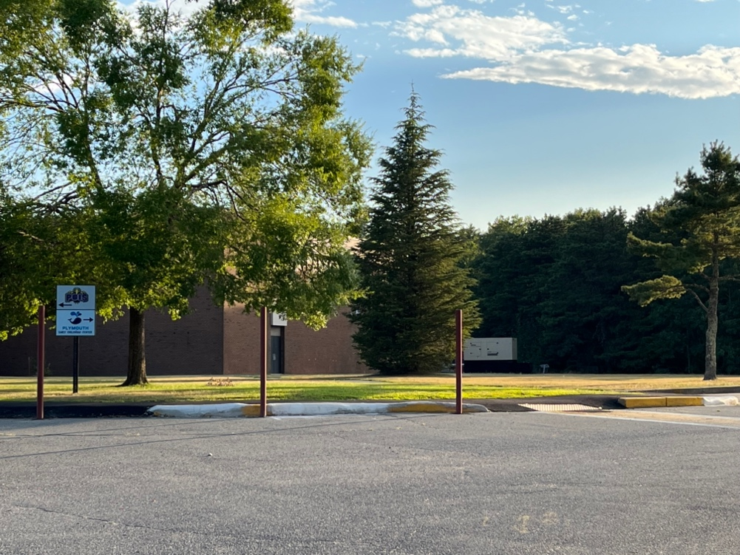

Set up some areas for grilling away from the trees with picnic tables with Restrooms nearby,

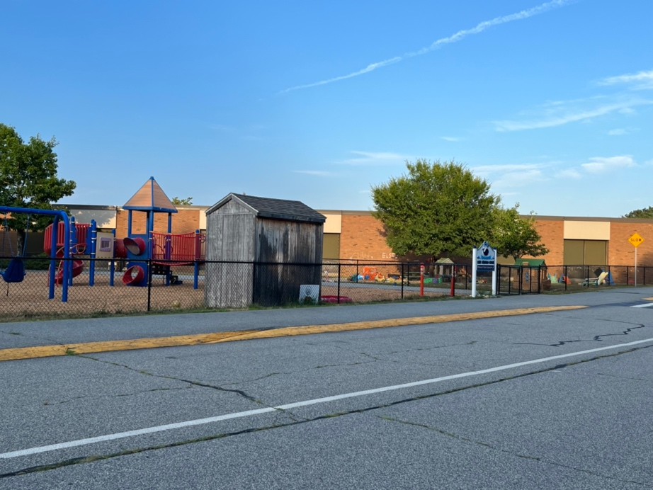

Playground for children here already

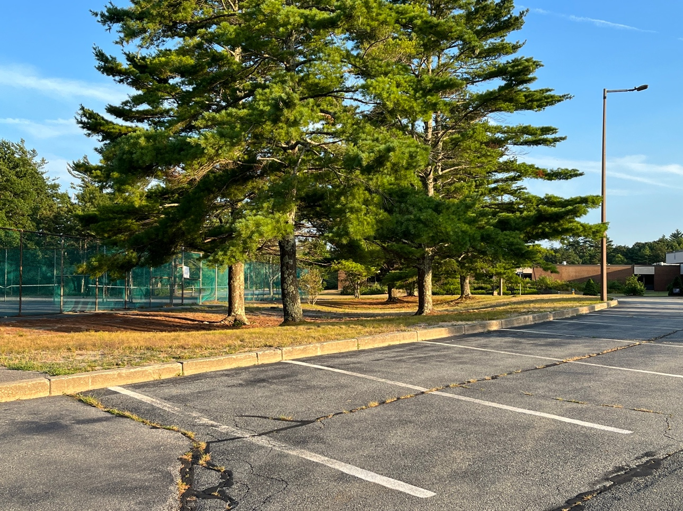

Tennis Courts and Ball Fields already here

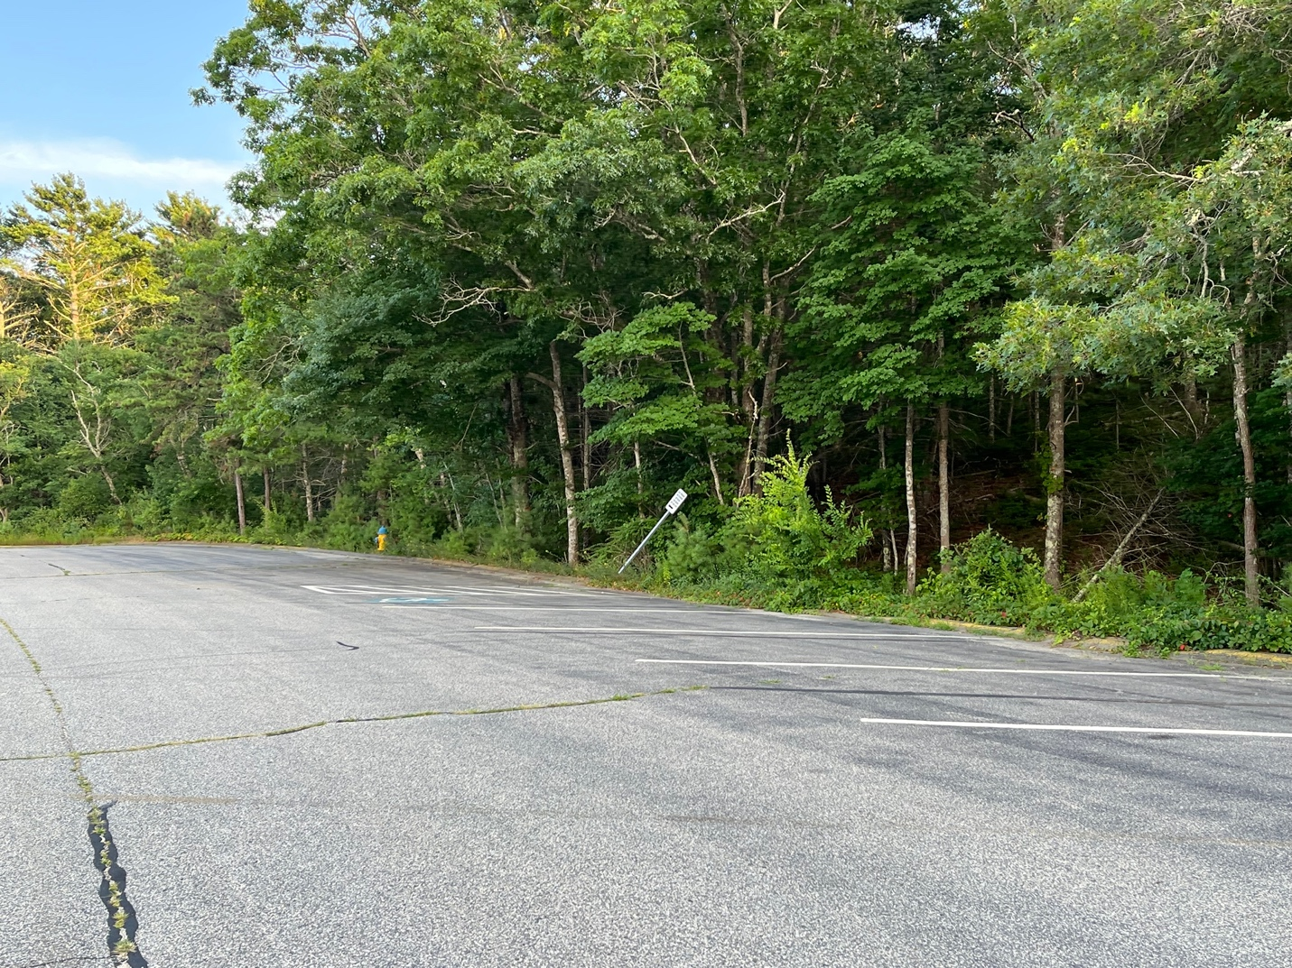

Town Forest nearby and walking trails. Could some of these areas be made more parklike and inviting with shaded place in the summer for picnics with tables and open areas? Provide some music?

Are the schools put to use on the weekend in the summer?

Lots of parking here which is usually a problem and limits use in other areas.