Great South Pond and Little South Pond 2021 and 2022

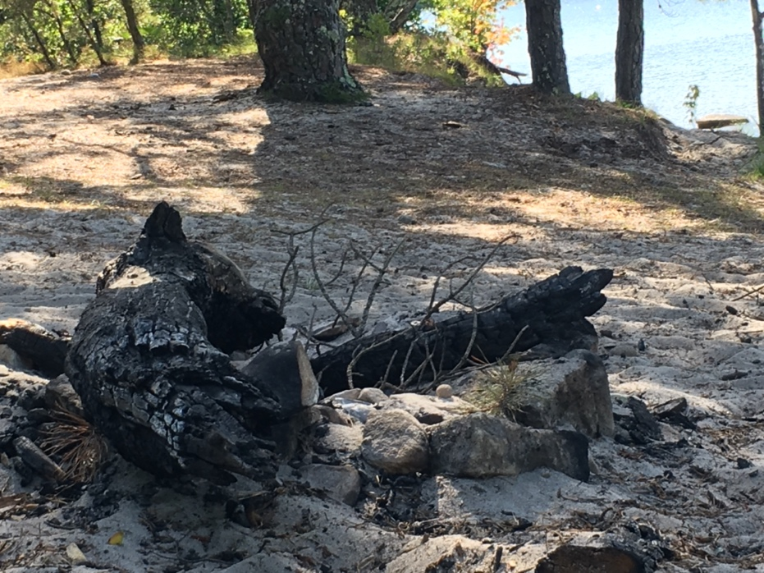

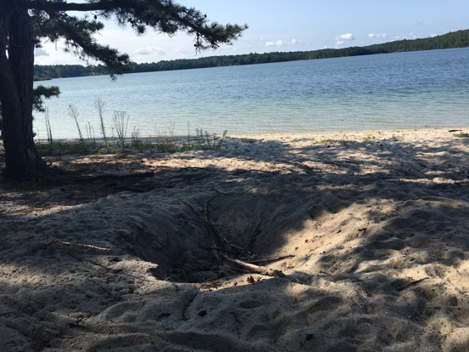 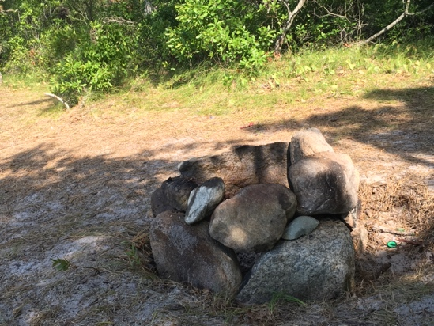

Great South Pond Beach 2021 fragile areas

Fire pits under the trees and cutting wood for fire and charcoal destroying the once beautiful beaches and under the trees. A threat to our forests and neighbohoods.

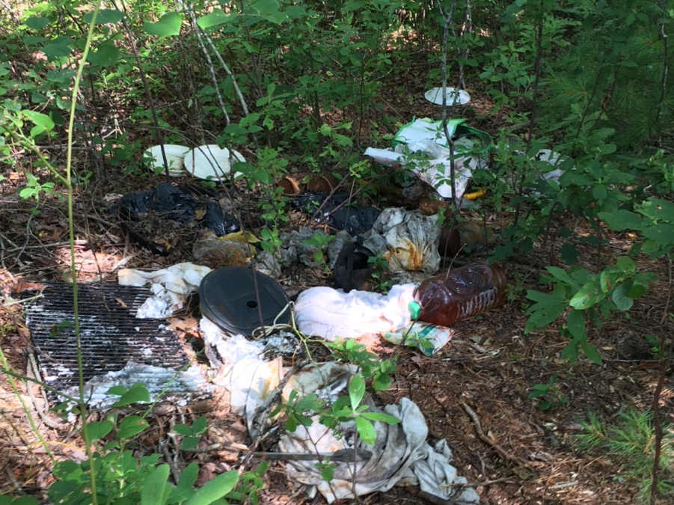 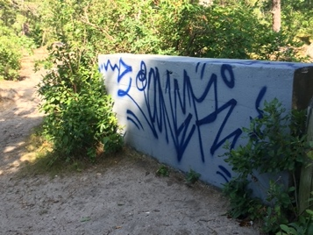

Disgusting. No restroom anywhere near. Grafitti on Aquaduct

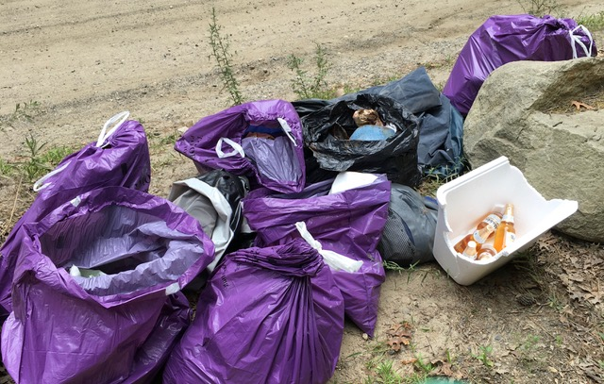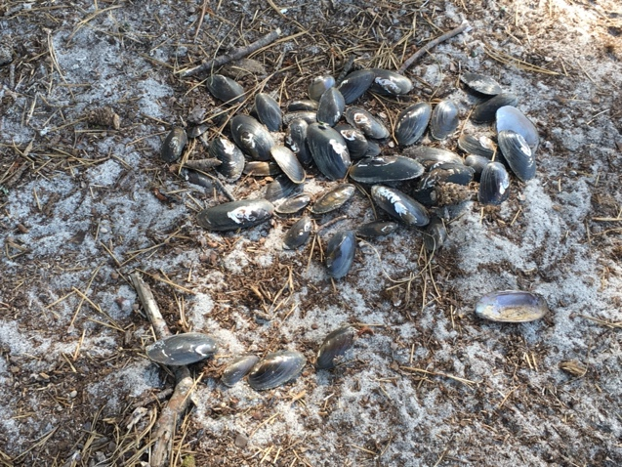

We cleaned up the entire area in 2020, and continue to do so. Native mussels?? Education needed if so.

Great Beach at Great South Pond 2022

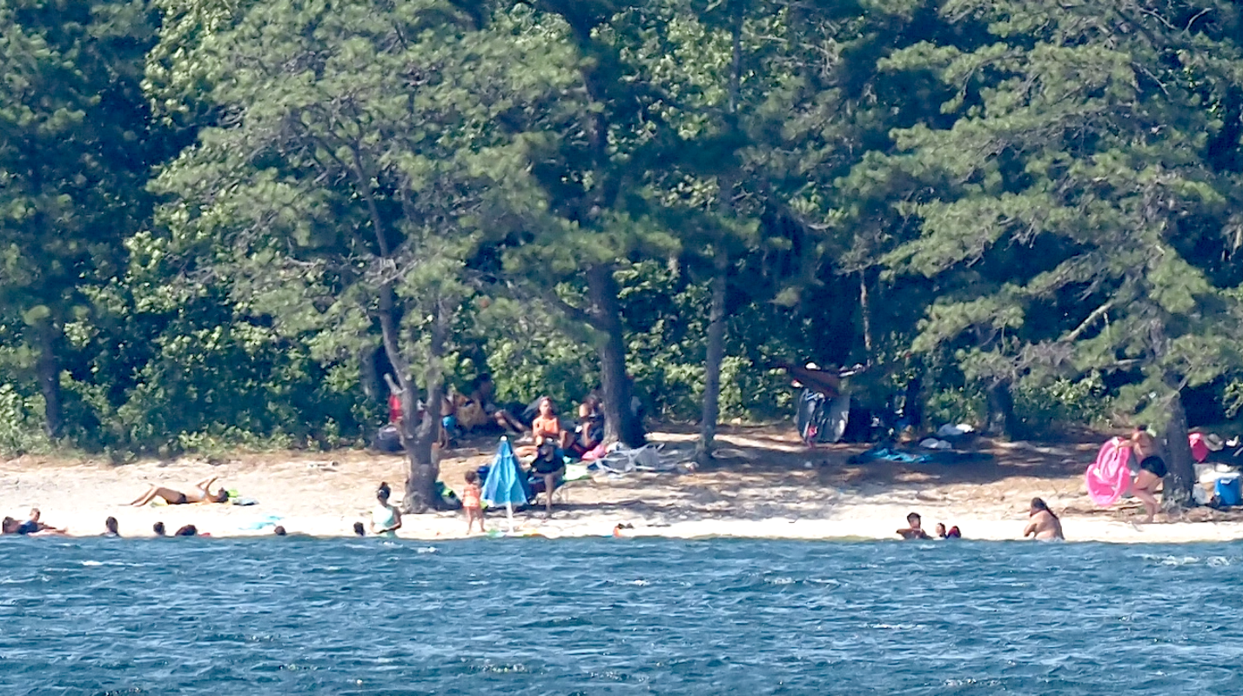

Desktop July weekend illegal swimming. One of the smaller gatherings on weekends this summer beachgoers all along the shore. Here for the day with grills, coolers, tents, blow up floaties, etc.

On the other side of Great South Pond West side in 2015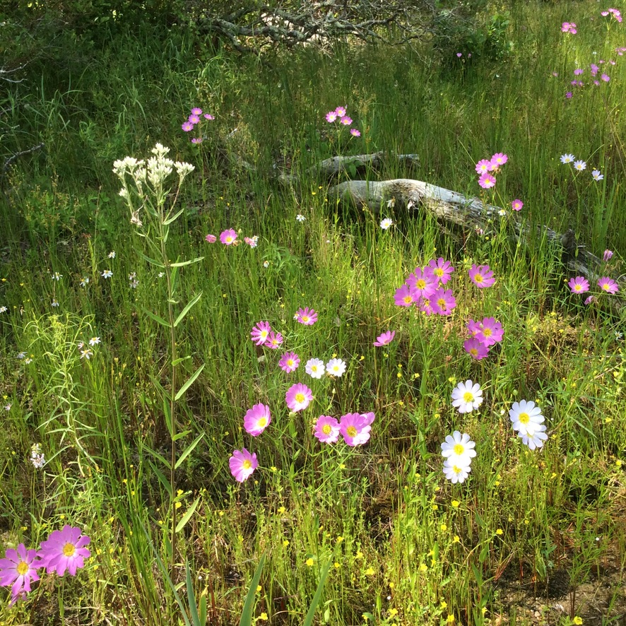

Plymouth Gentian and NE boneset, rose coreopsis all rare plants. 2015

When trampled these areas disappear. The protected areas are a biological a goldmine if they are preserved

**Cortelli Preserve** 2022 A small beach allowing rare plants to grow due to no public access in these areas.

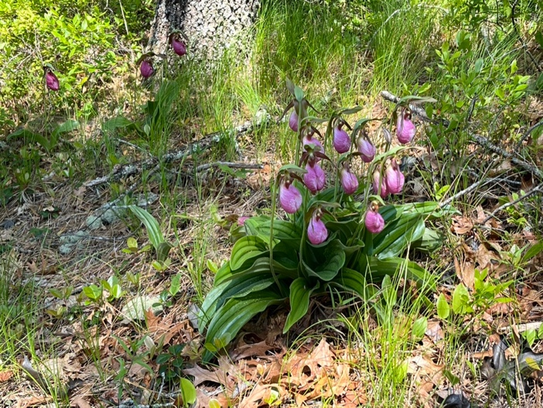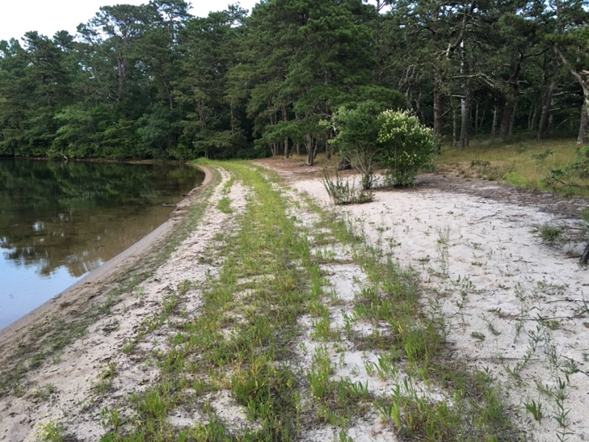

Upland areas on left. With patches of orchids spreading and this is the largest patch I have ever seen. Some areas need to be a corridor to other protected areas.

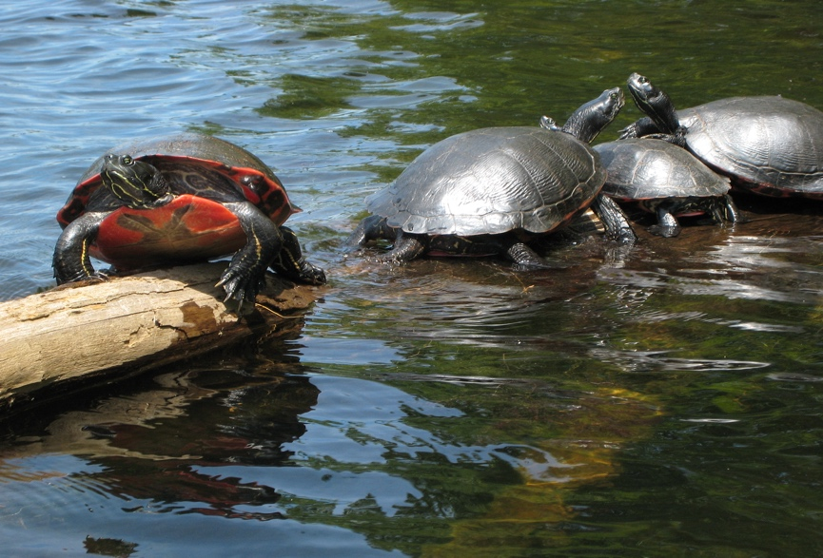 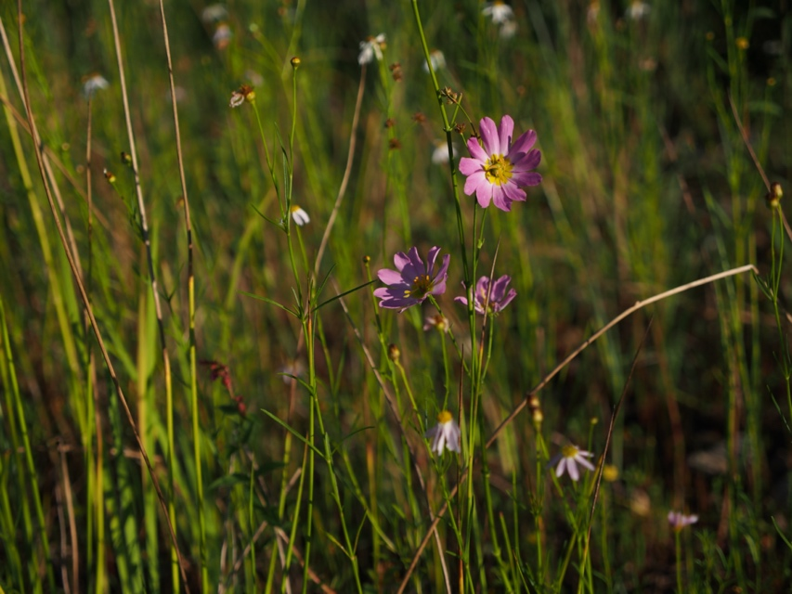

Cortelli early summer 2022 shows healthy shores top right rare plants emerging including the very rare N E. boneset. Lots of Endangered Northern Red-bellied Cooter in the coves in this end of the Great South Pond. The roads around this area have many nesting sites for the Cooters. Plymouth Gentian growing along the edges of the pond later in the season.