**West Wareham Fearing Hill forest**

**targeted by bankrupt solar company & land speculators**

***44 acres of industrial solar; toxic batteries risk fire, explosions in residential neighborhood***

**SOLAR SCHEME Bankrupt Colorado corporation** “Clean Energy Collective” has teamed up with **land speculators** **Joe Crespi and Robert Ahearn to propose an** industrial solar and energy storage facility on 44 acres of West Wareham forest. The land speculators **owe Wareham $217,370.00** from a tax fight with the Town & **bankrupt solar developer CEC** has sales that plummeted 97% in 2020. These speculators threaten our community! Site Plan Review Application, Option & Lease Agreement showing “Site Control” PDF page 80: [https:// www.wareham.ma.us/sites/g/files/vyhlif5146/f/pages/final_site_plan _review_application _binder_5-14-21.pdf](https://www.wareham.ma.us/sites/g/files/vyhlif5146/f/pages/final_site_plan_review_application_binder_5-14-21.pdf)

**THUMBING THEIR NOSE AT WAREHAM VOTERS** On June 12, 2021, Wareham Town Meeting voted unanimously to outlaw this type of industrial solar project -- 44 acres that cuts down trees --- but these developers want an exemption

**REAL ESTATE VALUES, RECREATION HARMED** The project abuts 44 homes in West Wareham residential neighborhood and 114 acre **Fearing Hill conservation land owned by the people of Wareham.** Industrial solar **reduces our property values** & will be an eyesore to users of the conservation land trails. University of Rhode Island Study: <https://web.uri.edu/coopext/files/PropertyValueImpactsOfSolar.pdf>

**DESTROYS FORESTS** The project will **destroy wild, woodland habitat and forest** in a **globally rare Pine Barrens ecosystem** with many **rare and protected species.**

**POLLUTES WATER** The important **Weweantic River watershed will be harmed** by the loss of forest cover that filters water and by stormwater runoff. This project will scrape vegetation and soil that protects and filters the **Plymouth Carver Sole Source Aquifer** - our drinking water.

**NOT CLEAN & GREEN, WE PAY** Massachusetts energy czars force ratepayers and taxpayers to give lavish subsidies to these developers claiming this is clean energy. The solar scheme can’t succeed without our subsidies! Do we want our money spent on this?

**SAFETY THREAT: EXPLOSIONS, FIRE, TOXIC CHEMICALS & WASTE** The project has 7,333 solar panels and massive 4.4 MW AC batteries that will be trash in 20 years and very expensive to get rid of. The batteries are unsafe and pose a risk of fire and explosion and can leak toxic chemicals into the ground overlying our aquifer. A fire could engulf the nearby forest, threatening residences. There is only one main access road that could cause a delayed fire department response. Harvard Business Review: <https://hbr.org/2021/06/the-dark-side-of-solar-power>

Explosion in Arizona: [https://www.azcentral.com/story/ money/business/energy/2020/07/27/aps-battery-explosion-surprise-new-report-findings/5523361002/](https://www.azcentral.com/story/money/business/energy/2020/07/27/aps-battery-explosion-surprise-new-report-findings/5523361002/)

**INJUSTICE!** Solar developers are preying on Wareham which has significant environmental justice and working class population dangling cash payments. Solar panel manufacturing often exploits workers - many are made in China by Uigher minorities under questionable labor practices. Lithium and cadmium mining for panels and batteries is destructive and often exploits workers and Indigenous communities.

**TAKE ACTION!**

All Town boards and committees must take a stand and reject this project!

**What:** Wareham Planning Board public hearing JUNE 28 at 6 p.m.to decide whether to grant “Special Permit Site Plan Review” under the Town’s Zoning Bylaws

**Where:** **Multi-Service Center 48 Marion Road, Wareham**

**Email, write and call:** 508-291-3100

George Barrett, Chair, Wareham Planning Board

Judith Whiteside, Chair Board of Selectmen jwhiteside@wareham.ma.us

Sandy Slavin, Chair Conservation Commission

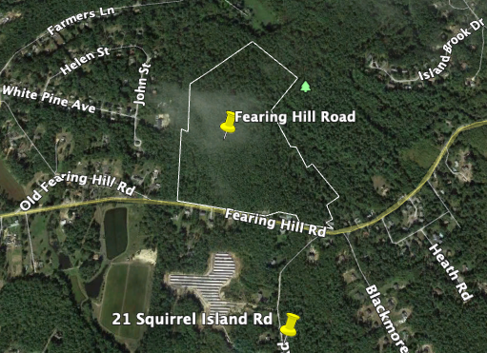

Proposed 44 acre solar site on Fearing Hill’s “The Grove”

www.savethepinebarrens.org

Facebook @LandWaterPlymouthArea

Twitter @SavePines

Instagram @savepinebarrens